Key Indicator - 1.2 Academic Flexibility (30)
1.2.1 Percentage of Programmes in which Choice Based Credit System (CBCS)/ elective course system has been implemented
(current year data)
Program code | Program name | Year of introduction | Status Of Implementation of CB CS/ Elective Course System (Yes / No) | Year Of Implementation of CBCS / Elective Course System | Link To Relevant Document
 | MA English | 2007 | Yes | 2008-09 | Link to Metric No.‐1.2.1
 | M.Sc (CS) | 2007 | Yes | 2008-09 | Link to Metric No.‐1.2.1
 | M.Sc General Chemistry | 2011 | Yes | 2008-09 | Link to Metric No.‐1.2.1
 | M.Sc Physics | 2015 | Yes | 2008-09 | Link to Metric No.‐1.2.1

Formula: 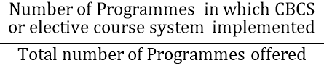 X 100

07/07x100 =100%

